**Latihan 1**

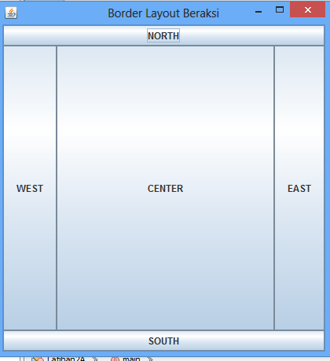package latihan2a;

import java.awt.BorderLayout;

import java.awt.Frame;

import javax.swing.*;

public class Latihan2A extends Jframe{

JButton nButt = new JButton("NORTH");

JButton sButt = new JButton("SOUTH");

JButton eButt = new JButton("EAST");

JButton wButt = new JButton("WEST");

JButton cButt = new JButton("CENTER");

public Latihan2A(){

super("Border Layout Beraksi");

setSize(1000, 780);

setDefaultCloseOperation(JFrame.EXIT_ON_CLOSE);

setLayout(new BorderLayout());

add(nButt, BorderLayout.NORTH);

add(sButt, BorderLayout.SOUTH);

add(eButt, BorderLayout.EAST);

add(wButt, BorderLayout.WEST);

add(cButt, BorderLayout.CENTER);

}

public static void main(String[] args) {

// TODO code application logic here

Latihan2A frame = new Latihan2A();

frame.setVisible(true);

}

}

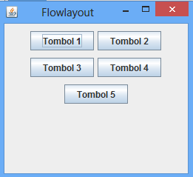**Latihan 2**

package latihan2b;

import javax.swing.JFrame;

import javax.swing.JButton;

import java.awt.Container;

import java.awt.FlowLayout;

public class Latihan2B extends JFrame {

public Latihan2B(){

FlowLayout flowlayout = new FlowLayout(FlowLayout.CENTER, 5, 10);

//Memperoleh konten pane dari frame

Container container = getContentPane();

//Mengatur layout manager dari content pane

container.setLayout(flowlayout);

//Menambahkan lima button ke content pane

container.add(new JButton("Tombol 1"));

container.add(new JButton("Tombol 2"));

container.add(new JButton("Tombol 3"));

container.add(new JButton("Tombol 4"));

container.add(new JButton("Tombol 5"));

}

public static void main(String[] args) {

// TODO code application logic here

Latihan2B jendela = new Latihan2B();

jendela.setTitle("Flowlayout");

jendela.setDefaultCloseOperation(JFrame.EXIT_ON_CLOSE);

jendela.setSize(320, 120); jendela.setVisible(true);

}

}

**Latihan 3**

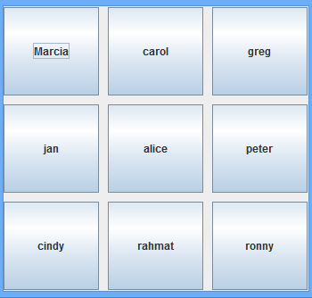package latihan2c;

import javax.swing.JFrame;

import javax.swing.JButton;

import java.awt.Container;

import java.awt.FlowLayout;

import java.awt.GridLayout;

import javax.swing.JPanel;

public class Latihan2C extends JFrame{

JButton marcia = new JButton("Marcia");

JButton carol = new JButton("carol");

JButton greg = new JButton("greg");

JButton jan = new JButton("jan");

JButton alice = new JButton("alice");

JButton peter = new JButton("peter");

JButton cindy = new JButton("cindy");

JButton rahmat = new JButton("rahmat");

JButton ronny = new JButton("ronny");

public Latihan2C() {

super(" Grid Layout Beraksi");

setSize(260, 260);

setDefaultCloseOperation(JFrame.EXIT_ON_CLOSE);

JPanel pane = new JPanel();

GridLayout family = new GridLayout(3, 3, 10, 10);

pane.setLayout(family);

pane.add(marcia);pane.add(carol);pane.add(greg);

pane.add(jan);pane.add(alice);pane.add(peter);

pane.add(cindy);pane.add(rahmat);pane.add(ronny);

add(pane);

setVisible(true);

}

public static void main(String[] args) {

Latihan2C frame = new Latihan2C() } }

**Latihan 4**

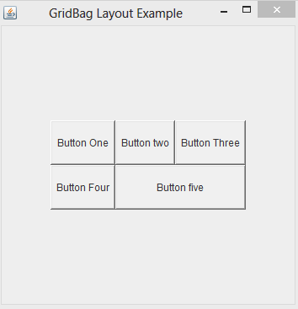package latihan2d;

import java.awt.Button;

import java.awt.GridBagConstraints;

import java.awt.GridBagLayout;

import javax.swing.*;

public class Latihan2D extends JFrame{

public static void main(String[] args) {

Latihan2D lat2 = new Latihan2D();

}

public Latihan2D(){

GridBagLayout grid = new GridBagLayout();

GridBagConstraints gbc = new GridBagConstraints();

setLayout(grid);

setTitle("GridBag Layout Example");

GridBagLayout layout = new GridBagLayout();

this.setLayout(layout);

gbc.fill = GridBagConstraints.HORIZONTAL;

gbc.ipady = 30;

gbc.gridx = 0;

gbc.gridy = 0;

this.add(new Button("Button One"), gbc);

gbc.ipady = 30;

gbc.gridx = 1;

gbc.gridy = 0;

this.add(new Button("Button two"), gbc);

gbc.fill = GridBagConstraints.HORIZONTAL;

gbc.ipady = 30;

gbc.gridx = 2;

gbc.gridy = 0;

this.add(new Button("Button Three"), gbc);

gbc.ipady = 30;

gbc.gridx = 0;

gbc.gridy = 1;

this.add(new Button("Button Four"), gbc);

gbc.gridx = 1;

gbc.gridy = 1;

gbc.fill = GridBagConstraints.HORIZONTAL;

gbc.gridwidth = 2;

this.add(new Button("Button five"), gbc);

setSize(300, 300);

setPreferredSize(getSize());

setVisible(true);

setDefaultCloseOperation(EXIT_ON_CLOSE);

}

}